
PUZZLES – Set 1

Below are several puzzles that can be printed out. Solutions have also been included. All the puzzles (except the math one) focus on sea ice research and geosciences in the Arctic.

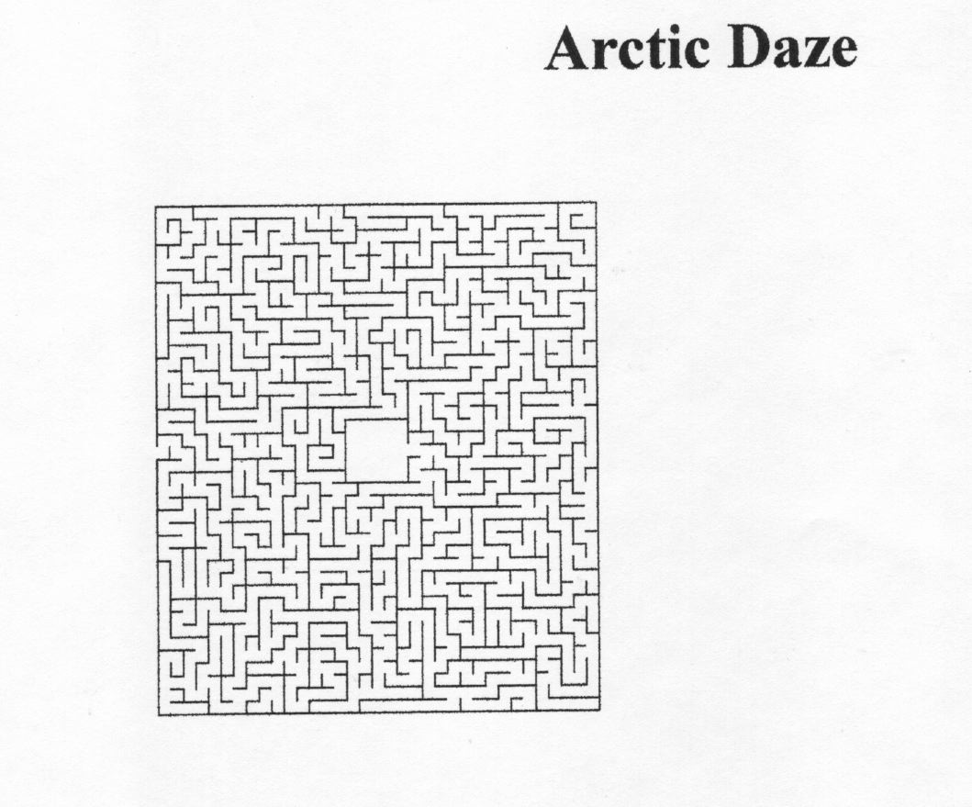
Good Luck and Have Fun!

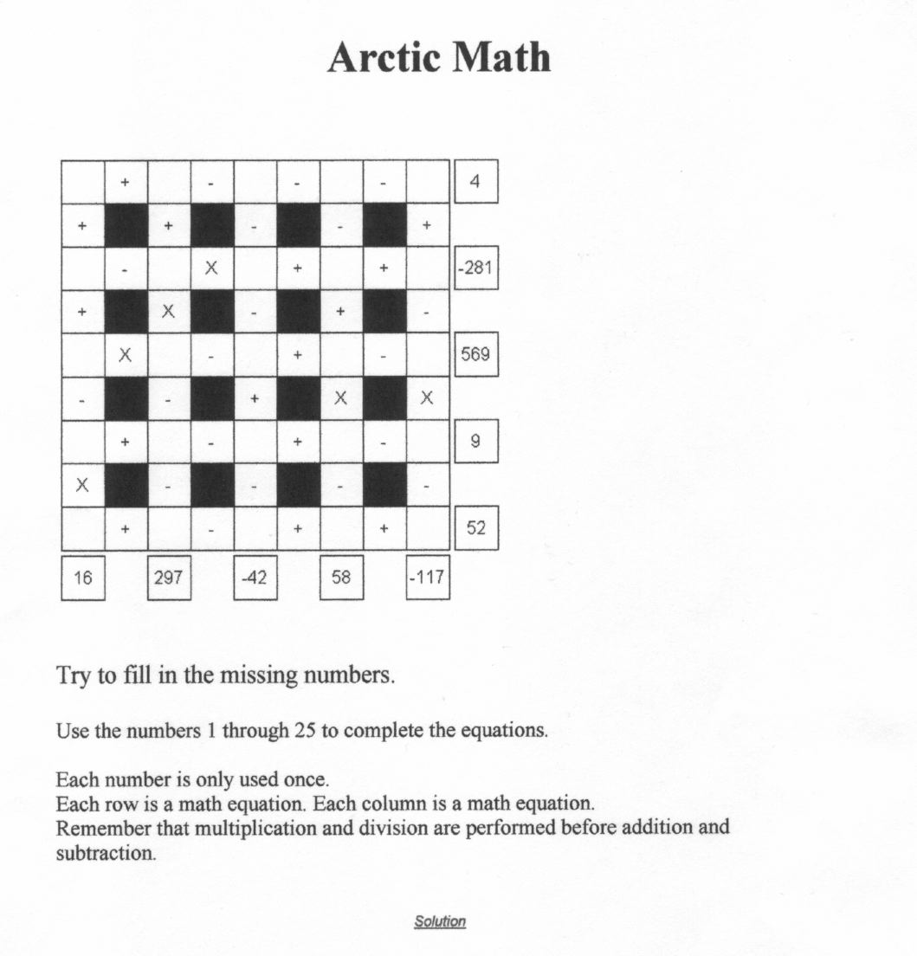

Solution to Arctic Math Puzzle:

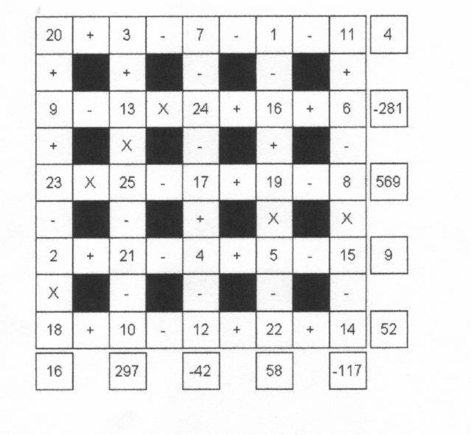

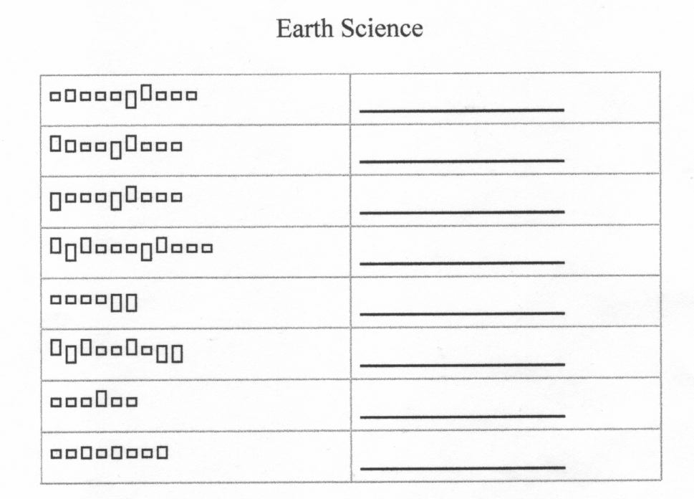
Directions: Match these words with their word shapes.

Carbon
Geosphere
Energy
Hydrology
Hydrosphere
Nutrient
Biosphere
Atmosphere

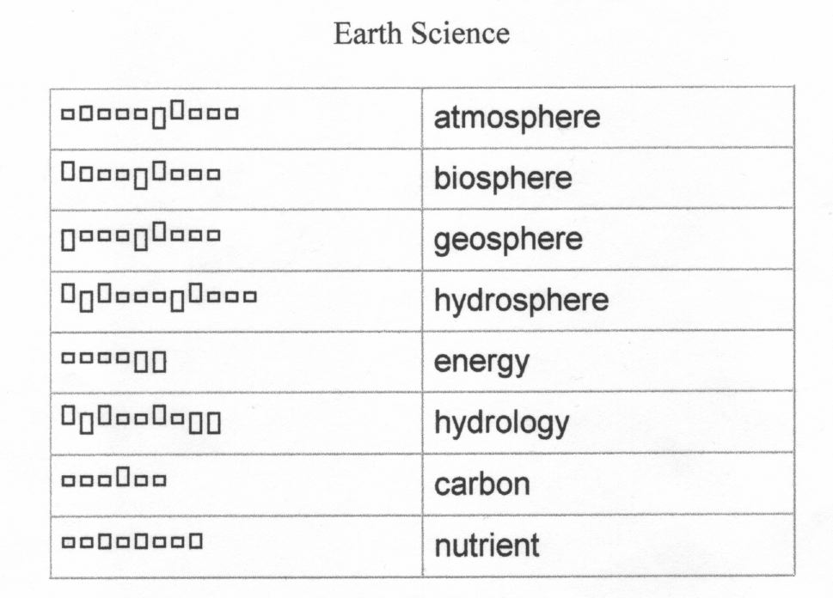
Solution to Earth Science Word Shape Puzzle:

