

Background Section II: Earth System Science

What are Earth’s Systems?
The Earth is comprised of various systems, such as, the atmosphere (air), biosphere (plants and animals, including humans), geosphere (land) and hydrosphere (water). Like the human body, which has many systems (circulatory, digestive, respiratory, reproductive, nervous, etc.) it is interactions between the systems that creates and maintains a stable environment for life to exist. The environment exists, as we know it today, because of the processes and interactions happening between the air, plants/animals, land and waters.

The following concepts about Earth Systems are reprinted from the National Science Education Standards:

Atmosphere
- Global patterns of atmospheric movement influence local weather. Oceans have a major effect on climate, because water in the oceans holds a large amount of heat.
- The atmosphere is a mixture of nitrogen, oxygen, and trace gases that include water vapor. The atmosphere has different properties at different elevations.
- Clouds, formed by the condensation of water vapor, affect weather and climate.

The atmosphere is the mixture of gases, listed below, and water vapor that surround the earth.
Nitrogen 78%
Oxygen 21%
Argon 0.94%
Carbon Dioxide 0.04%
Helium, Krypton, Neon, Xenon 0.02%

Biosphere
- Living organisms have played many roles in the earth system, including affecting the composition of the atmosphere, producing some types of rocks, and contributing to the weathering of rocks.

Geosphere
- The solid earth is layered with a lithosphere; hot, convecting mantle; and dense, metallic core. (See illustration below.)

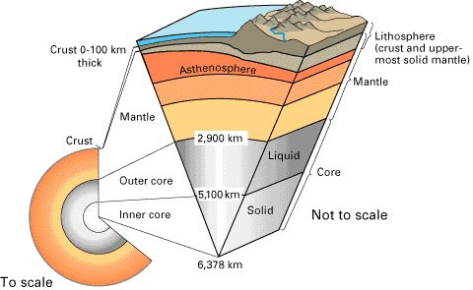

Cutaway views showing the internal structure of the Earth. Below: This view drawn to scale demonstrates that the Earth's crust literally is only skin deep. Below right: A view not drawn to scale to show the Earth's three main layers (crust, mantle, and core) in more detail.

Illustration and description from the U.S. Geological Survey. http://pubs.usgs.gov/publications/text/inside.html.

- Lithospheric plates on the scales of continents and oceans constantly move at rates of centimeters per year in response to movements in the mantle. Major geological events, such as earthquakes, volcanic eruptions, and mountain building, result from these plate motions.
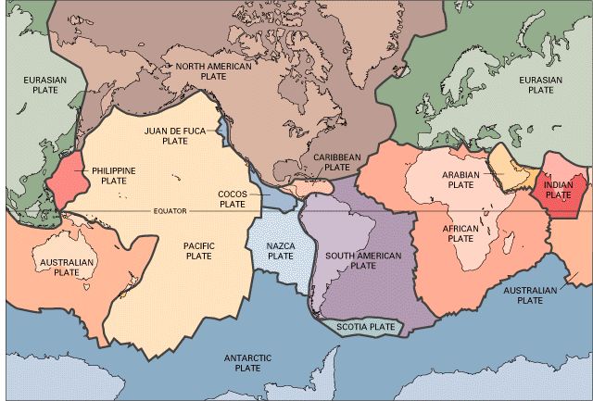

Illustration by U.S. Geological Survey. http://pubs.usgs.gov/publications/text/historical.html

- Landforms are the result of a combination of constructive and destructive forces. Constructive forces include crustal deformation, volcanic eruption, and deposition of sediment, while destructive forces include weathering and erosion.
- Some changes in the solid earth can be described as the "rock cycle." Old rocks at the earth's surface weather, forming sediments that are buried, then compacted, heated, and often recrystallized into new rock. Eventually, those new rocks may be brought to the surface by the forces that drive plate motions, and the rock cycle continues.

Hydrosphere
- Water, which covers the majority of the earth's surface, circulates through the crust, oceans, and atmosphere in what is known as the "water cycle." Water evaporates from the earth's surface, rises and cools as it moves to higher elevations, condenses as rain or snow, and falls to the surface where it collects in lakes, oceans, soil, and in rocks underground.
- Water is a solvent. As it passes through the water cycle it dissolves minerals and gases and carries them to the oceans.”

What are Earth’s Processes?
As with our circulatory system, which stores and transports water, oxygen and nutrients to the various part of the body, the earth systems hold and transport materials as well. Materials are stored in reservoirs and they move via pathways/processes to and from other systems.

There are many cycles or processes that occur on earth everyday. These processes are made possible because of the addition of energy from the sun.

- Energy Cycle

The sun is the major source of energy for phenomena on the earth's surface, such as growth of plants, winds, ocean currents, and the water cycle. Seasons result from variations in the amount of the sun's energy hitting the surface, due to the tilt of the earth's rotation on its axis and the length of the day. In addition, to the amount of energy available is the type of energy that is available.

There are many forms of energy (E) (Download Energy Cycle.pdf) For instance, energy can be in the form of: light or heat (like that of the sun), sound, electricity, motion/work, chemical (i.e. photosynthesis or muscular energy) or nuclear energy. Various forms of energy change into each other constantly. Energy is also the reason that materials, such as water, can change states and move through the water cycle. Using the diagrams of various cycles (water, carbon, etc.) identify the processes, for instance evaporation, where materials gain energy and move from one area to another.

- Hydrological Cycle

The hydrological (water) cycle provides a model for understanding the global plumbing system. Water spends time in the ocean, in the air, on the surface, and under the surface as groundwater. The hydrological cycle is a closed system because water is neither created nor destroyed on a large scale. Water exists as solid, liquid and gas phases that are interchangeable at temperatures found on earth. The hydrological cycle describes the movement of water as it passes through these phases. Water links the atmosphere, oceans and land through energy and matter exchanges as it evaporates, precipitates and flows.
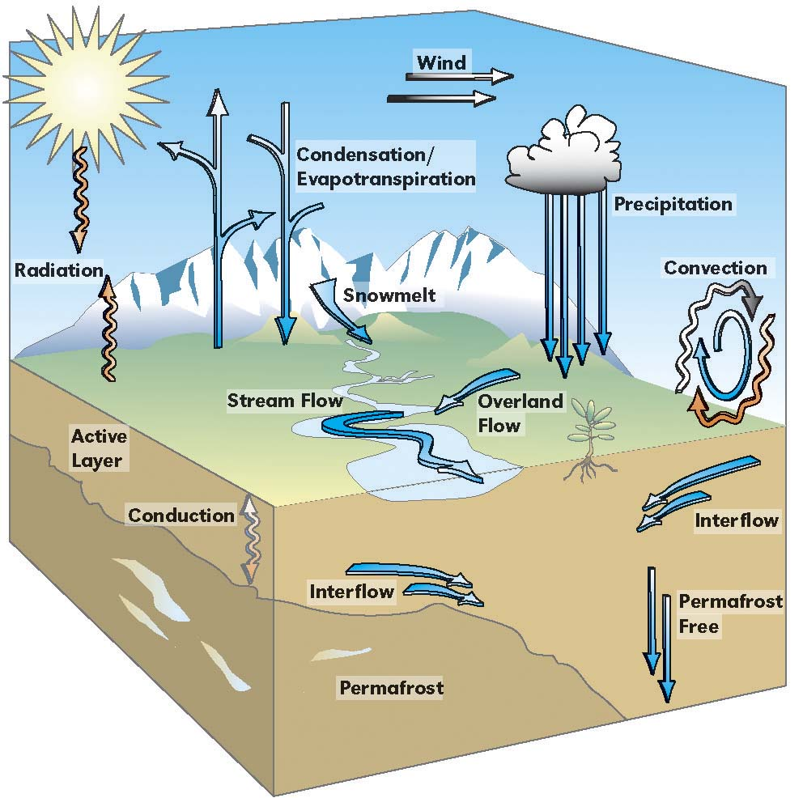

Illustration by Russ Mitchell for Arctic Research Consortium of U.S.

- Carbon Cycle

All life is based on the element carbon. Carbon is the major chemical constituent of most organic matter, from fossil fuels to the complex molecules (DNA and RNA) that control genetic reproduction in organisms. Carbon is stored on our planet in the following major sinks (1) as organic molecules in living and dead organisms found in the biosphere; (2) as the gas carbon dioxide in the atmosphere; (3) as organic matter in soils; (4) in the lithosphere as fossil fuels and sedimentary rock deposits such as limestone, dolomite and chalk; and (5) in the oceans as dissolved atmospheric carbon dioxide and as calcium carbonate shells in marine organisms.
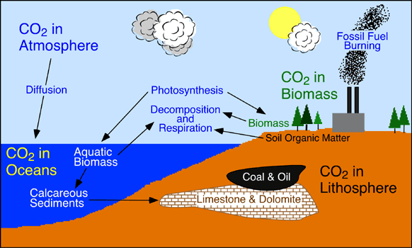

Illustration and carbon description from Department of Geography, Okanagan University College.

Ecosystems gain most of their carbon dioxide from the atmosphere. A number of autotrophic organisms have specialized mechanisms that allow for absorption of this gas into their cells. With the addition of water and energy from solar radiation, these organisms use photosynthesis to chemically convert the carbon dioxide to carbon-based sugar molecules. These molecules can then be chemically modified by these organisms through the metabolic addition of other elements to produce more complex compounds like proteins, cellulose, and amino acids. Some of the organic matter produced in plants is passed down to heterotrophic animals through consumption.

Carbon dioxide enters the waters of the ocean by simple diffusion. Once dissolved in seawater, the carbon dioxide can remain as is or can be converted into carbonate (CO3-2) or bicarbonate (HCO3-). Certain forms of sea life biologically fix bicarbonate with calcium (Ca+2) to produce calcium carbonate (CaCO3). This substance is used to produce shells and other body parts by organisms such as coral, clams, oysters, some protozoa, and some algae. When these organisms die, their shells and body parts sink to the ocean floor where they accumulate as carbonate-rich deposits. After long periods of time, these deposits are physically and chemically altered into sedimentary rocks. Ocean deposits are by far the biggest sink of carbon on the planet.

Carbon is released from ecosystems as carbon dioxide gas by the process of respiration. Respiration takes place in both plants and animals and involves the breakdown of carbon-based organic molecules into carbon dioxide gas and some other compound by products. The detritus food chain contains a number of organisms whose primary ecological role is the decomposition of organic matter into its abiotic components.

For a fun look at the carbon cycle, go to http://library.thinkquest.org/11226/index.htm.

- Nutrient Cycle

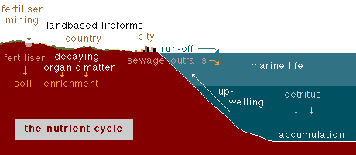

Illustration and caption with permission from Matthias Tomczak © 2000 M.Tomczak

The natural cycle consists of the recycling of decaying organic matter into land-based life forms on land and nutrient supply for marine from upwelling in the ocean.

The development of human civilization introduces the additional elements of sewage disposal and fertilizer application.

What are Geosciences?

Geosciences are sciences, such as physics, chemistry or geology, that are applied to the study the earth. Each piece of additional research continues to add to our understanding of how the earth systems and processes interact. Combining research from many fields helps to provide a complete picture to help us build accurate models of the earth. Accurate models can help us to predict outcomes or consequences of change, for instance, those changes associated with climate change.

It is becoming very clear to scientists that it will take a global research effort, combining knowledge from a variety of perspectives, to understand all the of the variables affecting the climate. Although, it is impossible to know everything, there are a few basic scientific facts that are important to know. These basic facts are applied across disciplines in a variety of studies to better understand the environment.

What are a few things I should know about Chemistry, Physics, and the Science of Light?

Chemistry

Chemistry is the study of the elements which form all existing substances. It covers their structure, how they combine to create other substances and how they react under various conditions. There are four areas of chemistry: physical, inorganic, organic, and environmental. For more information about chemistry and the periodic table go to the following web site: http://pearl1.lanl.gov/periodic/default.htm . To understand more about molecules, go to the following web site: http://www.recipnet.indiana.edu/common/common.html

About the Molecule Called “Water”:
One of the most important element is water. “Water is a substance made up of three atoms: two atoms of hydrogen and one atom of oxygen. These three atoms are held together by electrical forces, or bonds, in an arrangement called a molecule. Each hydrogen atom shares its electron with the oxygen atom creating a bond between the atoms.

- Vapor. This form of water has no shape or cohesion. It is created when water molecules are heated to such a fast and furious movement that the bonds linking them together break apart. Climate models predict that warmer temperatures will cause increased evaporation of water into the air.
- Liquid. In this form, each water molecule has stronger, more numerous bonds with its neighbors. Chilling the bonds tightens the bonds even further. If climate warms, the volume of the water in the oceans might increase and sea levels might rise. This volume increase would be due to two factors. First, if the oceans warm then water expands as it warms. Second, much water now locked into the polar ice caps would melt into liquid form.
- Ice. This form is cold, hard and rigid because each of its water molecules has many firm bonds with its neighboring molecules. Today land and sea ice reflects into space approximately 10 percent of the sunlight that reaches us, and helps to cool the earth.”
National Science Teachers Association. (1996). Forecasting the Future. Graphic Communications, Inc.

Physics

Physics is the study of the properties and nature of matter, the different forms of energy and the ways in which matter and energy interact in the world around us. To understand physics, you need to understand what matter is. For more information about physics, go to the following web site: http://kapili.com/m/modernphys.html

Some Laws of Physics
- Action (A) = Reaction(R)
Every action has an equal and opposite reaction.
- Energy is defined as the capacity to do work. The release of energy does work and doing work on something adds energy to it. Work and energy are equivalent.
- Law of Conservation of Energy
The total energy of a system does not change (it is neither created nor destroyed) it is simply converted to another form

The Science of Light

Light interacts with matter by transmission (including refraction), absorption or scattering (including reflection). This concept becomes important in regards to climate change because the amount of energy/light that is absorbed by the planet not only is available for use in earth processes (i.e. for evaporation) this energy can also be trapped within the earth system as heat. Therefore, the amount of energy reflected back into space and the amount absorbed by the planet have impacts on the temperature of the earth.

To understand more about the light spectrum, refraction, and reflection, check out the following web sites:

http://imagers.gsfc.nasa.gov/ems/visible.html

http://www.kapili.com/l/light.html

