

Background Section III: Climate and Climate Change Research

This background section explains three major concepts:

What is climate?

What is climate change?

What is the greenhouse effect?

Climate and climate change terms

Weather is the condition of the atmosphere at any given place and time involving factors such as temperature, precipitation, direction and speed of wind, and the amount of water vapor in the air.

Climate is the long-term average of a region’s weather events from season to season and year to year.

Climate Change represents a change in these long-term weather patterns. They can become warmer or colder; annual amounts of rainfall or snowfall can increase or decrease.

Global Warming refers to an average increase in the earth’s temperature, which in turn causes changes in climate. Overall warming of the planet can have very different regional affects. Warm wet weather might occur in one location while cold and dry weather occur elsewhere. Evidence that global warming is occurring include
- a global mean surface temperature that has increased between 0.5 and 1.1 degrees Fahrenheit since the late 19th century;
- recent years have been among the warmest this century;
- melting of glaciers and polar sea ice;
- sea level rise;
- reports of Spring arriving earlier and Fall later in the Northern Hemisphere.

Greenhouse Effect is a natural phenomenon. It works in the following way. A warming results when atmospheric gases, like carbon dioxide or water vapor, trap heat radiating from the earth and interrupt its course toward space. “Greenhouse gases” trap heat in the atmosphere as the windows on a greenhouse allow sunlight through but prevent the warm air from escaping.

Without this process the Earth would be a frigid planet. However, human activities, such as burning fossil fuels to power our cars, homes and factories release carbon dioxide and other greenhouse gases, are thereby intensifying this natural occurrence.

Greenhouse Gases, particulate or aerosols occur both naturally (i.e. volcanic dust or desert sand) and as a result of human activity and manufacturing (i.e. fluorocarbons). When scientists refer to “greenhouses gases”, they mean
carbon dioxide Released in the process of burning i.e. wood, fossil fuels and
absorbed by plants in the process of respiration.
water vapor Water molecules in the atmosphere as a result of evaporation.
methane Primary sources include bogs, swamps, rice fields, landfills, and the guts of termites and cows.
nitrous oxide Found naturally in tropical soils and oceans and man-made in fertilizers.
fluorocarbons Found in coolants and insulators in refrigerators and air conditioners.

Questions to ask about climate and climate change

- How do we study and predict global climate change?

- Scientific Research and Modeling

A model is a smaller representation of something larger and more complex. Scientists use models to help study, understand and predict the natural world. “The behavior of the climate system can be simulated with computer models called general circulation models (GCMs). GCMs are computer representations of global climate that are used to make climate change predictions.” NOAA/NASA/EPA. What the Experts say about Climate Change.

For models to be useful and accurate tools they must be designed and developed based on the most current and accurate scientific research and they must be updated as new knowledge and understanding becomes available. For instance, the Arctic plays a key role in global climate change. As scientists continue to learn more about the processes and interactions in the Arctic they can refine their models about how specific changes in the Arctic will affect the global climate. The diagram illustrates some of the Arctic processes that affect climate change, can you identify those processes?
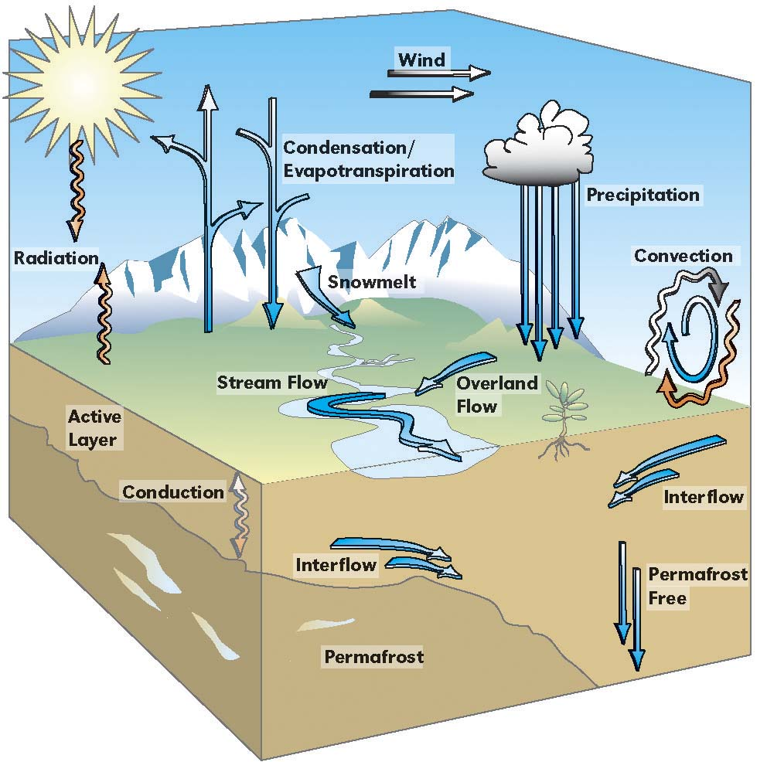

Local Knowledge

The term “local knowledge” as used here refers to knowledge and understanding that residents have about their community and region. That knowledge is often in the form of traditional Native knowledge. “Contributions of traditional knowledge have been well documented in several areas, including biological information and ecological insights, resource management, protected areas, biodiversity conservation, environmental assessment, social development and environmental ethics…However, very little research has been done to explore the value of traditional knowledge related to climate and climate change research. We propose five areas of potential convergence to link traditional knowledge with Western science.
- Local Scale Expertise – Understanding the impacts of global warming for the local/regional area.
- Climate history and baseline data - …Traditional knowledge, through cumulative experience and oral history, provides insights into past climate variability and fluctuation; such knowledge is embedded in Inuit history of wildlife populations, travels, unusual events, harvesting records and migrations.
- Formulating research questions and hypotheses – Traditional knowledge may expand the range of concepts and possibilities upon which to base research questions and formulate hypotheses.
- Impacts and Adaptations: How Inuit see change – Human dimensions of change, including planning and understanding human adaptation, is an important aspect of climate change research but poorly understood (IPCC 1995; Maxwell 1997; Smithers & Smit 1997). Including traditional knowledge in adaptation research can establish the changes that the communities see, how the perceive them, and how they explain these changes in the context of livelihoods.
- Community-based environmental monitoring – Environmental monitoring occurs in the context of seasonal rounds of resource harvesting activities; it is closely tied to travel routes and the times and places of harvesting. This kind of community-based monitoring ensures that ecological relationships are noted…
These areas are a framework to facilitate the linkage of traditional knowledge with Western science for collaborative climate change research. Traditional knowledge represents another approach and perspective to researching global climate change by comparing what is happening at present to what has happened in the past.”
Text paraphrased from:
Riedlinger, Dyanna. (2000). Contributions of Traditional Knowledge to Understanding Climate Change in the Canadian Arctic. University of Manitoba.

- What are some of the technologies that we have available to assist in our studies?

Models are improved through collection of scientific information about the earth and its processes. There are a number of technologies that are available as tools for scientific research about the earth’s climate (see the following link http://www.epa.gov/globalwarming/publications/outreach/basics/howtotake.pdf.)

- What is sea ice?

“Sea Ice is a thin, fragile, solid layer that forms in Polar Oceans. It forms a boundary between relatively warm ocean and the cooler atmosphere. There are many different kinds of sea ice.” http://southport.jpl.nasa.gov/polar/iceinfo.html For more information about sea ice visit (http://www.arcticice.org/seaice.htm).

- What does sea ice have to do with climate change?

Many things can be studied about sea ice that might give us insights to climate change. Some things that scientists research about sea ice include its type, motion, thickness, concentration, margins, albedo, etc. The ice itself can also be analyzed for data.

Albedo Research
Sea ice, generally, reflects light and has a cooling effect on the planet. Scientists study the reflective properties of sea ice or its albedo. (See background section, “The Science if Light” to review the concepts of reflection and absorption.) Even though the Arctic receives a large amount of solar energy in summer, the high reflectivity (albedo) of snow and ice surfaces keeps absorption of solar energy low. Therefore, the heat gained during the long summer days is small and highly dependent on surface properties such as topography and albedo. For instance, wet tundra and bare ground (with low albedo) absorb more solar radiation than do high-albedo ice sheets. Similarly, wet snow absorbs more radiation than dry snow.” The amount of solar radiation absorbed or reflected impacts the global climate.
- Taken from the NSIDC Arctic Climatology and Meteorology Primer (http://nsidc.org/arcticmet/)

For more information about albedo go to: http://www.arcticice.org/earthalb.htm

This interaction between albedo and temperature is an example of a feedback loop. “A feedback loop is a pattern of interacting processes where a change in one variable, through interaction with other variables in the system, either reinforces the original process (positive feedback) or suppresses the process (negative feedback).” In the example described above and as illustrated in the diagram, increased temperature, causes more ice melting, which causes less reflection of solar radiation back to space, which in turn causes more warming (a positive feedback).
Taken from the NSIDC Arctic Climatology and Meteorology Primer (http://nsidc.org/arcticmet/)

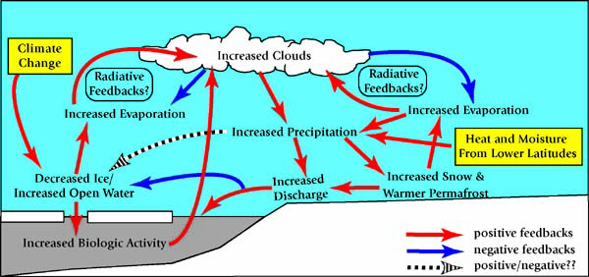

Ice Core Research
Sea ice is also valuable in researching climate change because the ice holds a historical record of the past climate and conditions. “Ice cores drilled from the ice sheet provide a sample of all the layers of snow accumulated over thousands of years, the oldest at the bottom. Once a site is selected, a drill is set up and the coring begins. Mechanical drills can penetrate up to 3 feet (1 m) at a time before being withdrawn for the core to be recovered. To reach the 200-year depth, the team will have to drill 160-230 feet (50-70 m) which will typically take about a day.

Ice cores are usually about 3 inches (10 cm) in diameter. As they are brought to the surface a scientist will examine the core and attempt to place that section of core in time. Alternating bands of light and dark snow can been seen when light is shone through the ice core from behind. The light layers represent summer snow and the dark layers are winter snow. By keeping track of the individual layers they can be counted in much the same way as tree rings. More sophisticated techniques for dating ice cores are done later back in the laboratory by analyzing the concentration of oxygen atoms in the ice. Additionally, with the use of microscopy, observations about the contents, structure and formation of the ice itself can provide researchers with valuable clues about past conditions.

Climatic parameters such as air temperature, precipitation rate, and solar radiation, among other things can be interpreted from ice cores. By studying this record, scientists can identify the natural cycles in climate.”
Paraphrased from www.secretsoftheice.org/icecore/studies.html

- What are some possible consequences of climate change?

Based on current climate models some projections are:
- Increasing temperature, “models predict 5-9 degrees Fahrenheit (3-5 degrees Celsius) in the next 100 years”. US Global Change research Program. (2001). Climate Change Impacts on the United States. Cambridge University Press.
- Change in rainfall patters; likely increased precipitation in some areas and draught in others; more severe or extreme weather events
- Sea level rise, bank destruction, storms
- Sea Ice, ice-sheets, permafrost and glaciers melting; increased freshwater runoff/erosion into the oceans
- Possible change in atmospheric and ocean currents
- Continuing change in the chemical composition of the ocean and atmosphere

As a result of warming, the consequences for flora and fauna (including humans) will vary depending on conditions and change occurring in a particular location and the adaptability of the species in question.
- Climate change is projected to cause a change in distribution of ecosystems; causing a shift or possible extinction for systems that are extreme or susceptible to change.
- Plants are especially susceptible to changes in the environment because of their sedentary nature.
- Ectotherms, cold-blooded animals which do not regulate their internal temperatures, such as reptiles and amphibians are more affected by change.
- For specific effects climate change may have in the Arctic please see the tables.

